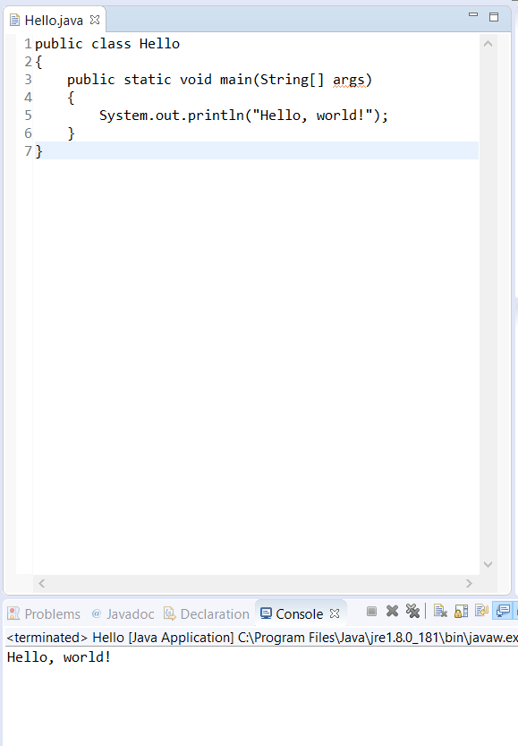

Hello.java compiled and run. First time using and IDE since taking C++ in high school. Slightly different than coding text editors; vs code, Atom, Brackets, n++. Having to compile to see changes will also be a slight change.

Errors:

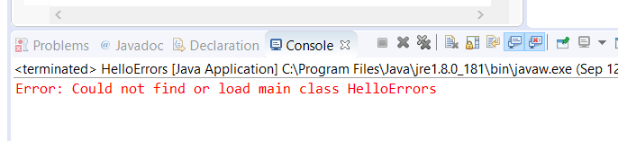

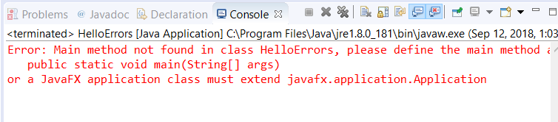

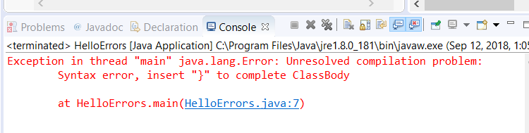

Comments:

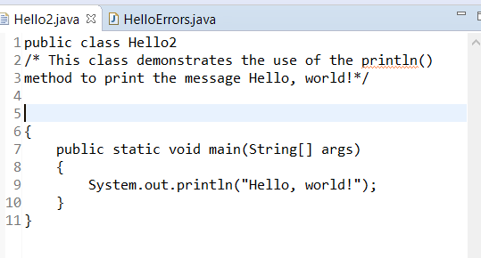

Hello World Dialog Box:

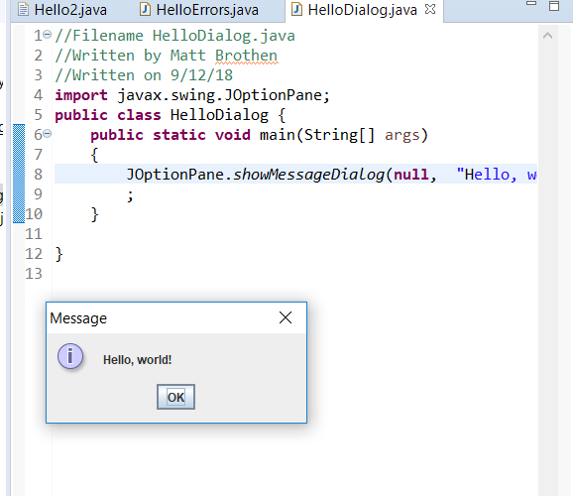

Java website:

